UNITED STATES

SECURITIES AND EXCHANGE COMMISSION
Washington, D.C. 20549

FORM 8-K

CURRENT REPORT

Pursuant to Section 13 or 15(d)
of the Securities Exchange Act of 1934

Date of Report (Date of earliest event reported): June 23, 2020

REPARE THERAPEUTICS INC.

(Exact name of registrant as specified in its charter)

Québec | 001-39335 | Not applicable
((State or Other Jurisdiction | (Commission | (I.R.S. Employer
of Incorporation) | File Number) | Identification No.)
7210 Frederick-Banting, Suite 100
St-Laurent, Québec, Canada |  | H4S 2A1
(Address of Principal Executive Offices) |  | (Zip Code)
 | (857) 412-7018
 | (Registrant’s Telephone Number, Including Area Code)
 | Not Applicable
 | (Former Name or Former Address, if Changed Since Last Report)

Check the appropriate box below if the Form 8-K filing is intended to simultaneously satisfy the filing obligation of the registrant under any of the following provisions (see General Instruction A.2. below):

- Written communications pursuant to Rule 425 under the Securities Act (17 CFR 230.425)

- Soliciting material pursuant to Rule 14a-12 under the Exchange Act (17 CFR 240.14a-12)

- Pre-commencement communications pursuant to Rule 14d-2(b) under the Exchange Act (17 CFR 240.14d-2(b))

- Pre-commencement communications pursuant to Rule 13e-4(c) under the Exchange Act (17 CFR 240.13e-4(c))

Securities registered pursuant to Section 12(b) of the Act:

 | Title of each class |  | Trading Symbol(s) | Name of each exchange on which registered
 | Common Shares |  | RPTX |  | The Nasdaq Stock Market LLC

Indicate by check mark whether the registrant is an emerging growth company as defined in as defined in Rule 405 of the Securities Act of 1933 (§ 230.405 of this chapter) or Rule 12b–2 of the Securities Exchange Act of 1934 (§ 240.12b–2 of this chapter).

Emerging growth company ☒

If an emerging growth company, indicate by check mark if the registrant has elected not to use the extended transition period for complying with any new or revised financial accounting standards provided pursuant to Section 13(a) of the Exchange Act. ☐

Item 5.03. Amendments to Articles of Incorporation or Bylaws; Change in Fiscal Year.

Articles of Continuance

On June 23, 2020, Repare Therapeutics Inc. (the “Company”) filed its articles of continuance (the “Articles”) with the Registraire des entreprises of the province of Québec in order to, among other things, continue the Company from the Canada Business Corporations Act to the Business Corporations Act (Québec) in connection with the closing of the Company’s initial public offering of shares of its common shares (the “IPO”). The Company’s board of directors and shareholders previously approved the Articles on June 10, 2020, to be effective upon the closing of its IPO. A description of certain provisions of the Articles is set forth in the section titled “Description of Share Capital” in the final prospectus the Company filed with the U.S. Securities and Exchange Commission on June 19, 2020 pursuant to Rule 424(b) under the Securities Act of 1933, as amended, relating to the Registration Statement on Form S-1, as amended (File No. 333-238822) (the “Prospectus”).

The foregoing description of the Articles is qualified in its entirety by reference to the full text of the Articles, which is filed as Exhibit 3.1 hereto, and is incorporated herein by reference.

Amendment and Restatement of Bylaws

Effective as of June 23, 2020, the Company adopted amended and restated bylaws (the “Restated Bylaws”) in connection with the closing of the IPO. The Company’s board of directors and shareholders previously approved the Restated Bylaws on June 10, 2020, to be effective immediately prior to the closing of its IPO. A description of certain provisions of the Restated Bylaws is set forth in the section of the Prospectus titled “Description of Share Capital.”

The foregoing description of the Restated Bylaws is qualified in its entirety by reference to the full text of the Restated Bylaws, which is filed as Exhibit 3.2 hereto, and is incorporated herein by reference.

Item 8.01. Other Events.

On June 23, 2020, the Company issued a press release announcing the closing of its initial public offering of 12,650,000 of its common shares, which includes the exercise in full of the underwriters’ option to purchase an additional 1,650,000 common shares, at a public offering price of $20.00 per share. The gross proceeds to the Company from the IPO were $253.0 million, before deducting underwriting commissions and estimated offering expenses payable by the Company.

A copy of the press release is attached hereto as Exhibit 99.1 and is incorporated by reference herein.

Item 9.01. Financial Statements and Exhibits.

(d) Exhibits.

Exhibit | Description
No.
3.1 | Articles of Continuance of Repare Therapeutics Inc.
3.2 | Amended and Restated Bylaws of Repare Therapeutics Inc.
99.1 | Press Release, dated June 23, 2020.

SIGNATURES

Pursuant to the requirements of the Securities Exchange Act of 1934, the registrant has duly caused this report to be signed on its behalf by the undersigned hereunto duly authorized.

REPARE THERAPEUTICS INC.

By: /s/ Lloyd M. Segal

Lloyd M. Segal

President and Chief Executive Officer

Dated: June 23, 2020

Exhibit 3.1
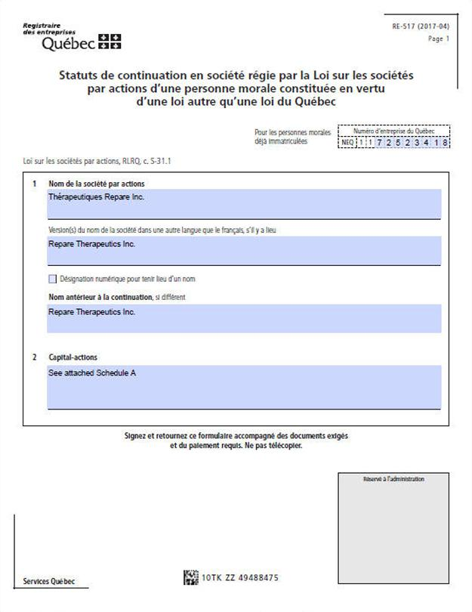

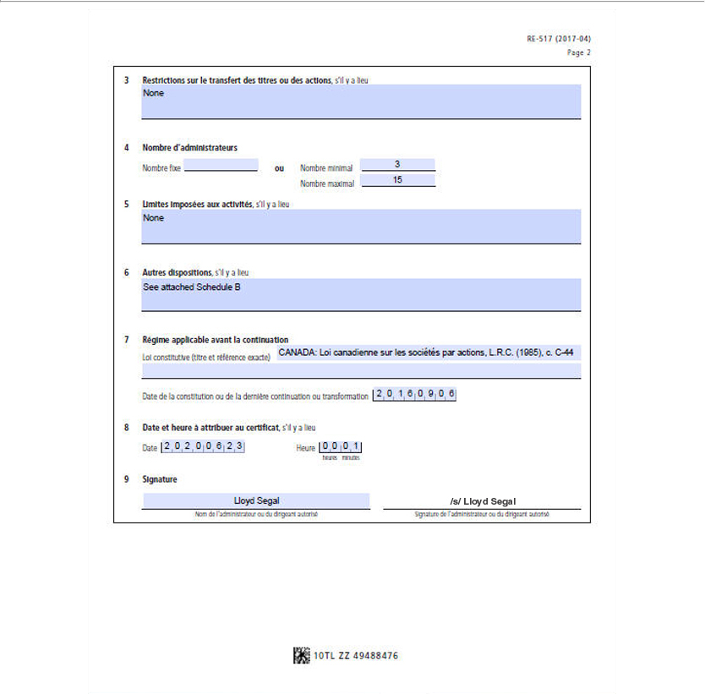

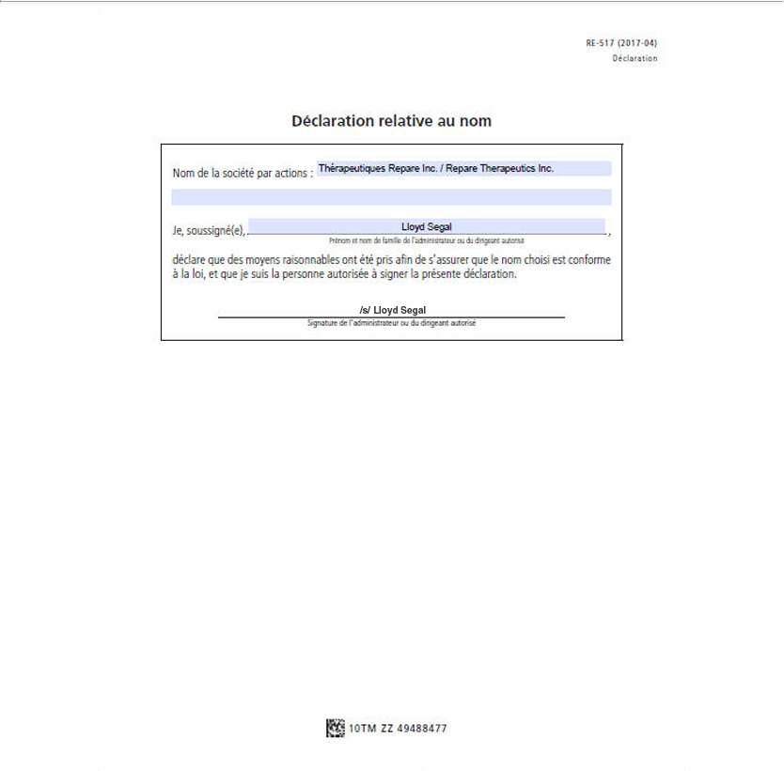

SCHEDULE A

Description of share capital

Unlimited number of common shares; and

Unlimited number of preferred shares, issuable in series.

- The common shares shall have attached thereto the following rights and restrictions:

1.1. Voting. Each common share shall entitle the holder thereof to one (1) vote at all meetings of the shareholders of the Corporation (except meetings at which only holders of another specified class of shares are entitled to vote pursuant to the provisions hereof or pursuant to the provisions of the Business Corporations Act (Quebec) (hereinafter referred to as the “Act”)).

1.2. Dividends. The holders of the common shares shall be entitled to receive, as and when declared by the board of directors of the Corporation (the “Board”), subject to and subordinate to the rights, privileges, conditions and restrictions attaching to the preferred shares and the shares of any other class ranking senior to the common shares, dividends payable in money, property or by the issue of fully paid shares of the share capital of the Corporation or options or right to acquire fully paid shares of the Corporation.

1.3. Liquidation, etc. In the event of the liquidation, dissolution or winding-up of the Corporation, whether voluntary or involuntary, or other distribution of property of the Corporation among shareholders for the purpose of winding up its affairs, subject to and subordinate to the rights, privileges, conditions and restrictions attaching to the preferred shares and the shares of any other class ranking senior to the common shares, the holders of the common shares shall be entitled to receive the remaining property of the Corporation.

- The preferred shares shall have attached thereto the following rights and restrictions:

2.1. Series. The Board may, at any time and from time to time, issue the preferred shares in one or more series, each series to consist of such number of shares as may, before issuance thereof, be determined by the Board.

2.2. Terms of Each Series. The Board may, in the manner hereinafter provided, from time to time fix, before issuance, the designation, rights, privileges, restrictions and limitations attaching to the preferred shares of each series, including, without limiting the generality of the foregoing, the rate, amount or method of calculation of preferential dividends (whether cumulative or non-cumulative or partially cumulative, and whether such rate, amount or method of calculation shall be subject to change or adjustment in the future), the currency or currencies of payment, the date or dates and place or places of payment thereof and the date or dates from which such preferential dividends shall accrue, the

redemption price and terms and conditions of redemption, if any, the rights of retraction, if any, vested in the holders of preferred shares of such series and the prices and the other terms and conditions of any rights of retraction, and any additional rights of retraction which may be vested in such holders in the future, voting rights and conversion, exchange or reclassification rights, if any, any sinking fund, purchase fund or other provisions attaching to the preferred shares of such series, and any other terms not inconsistent with these provisions, the whole subject to the issuance of a certificate of amendment in respect of articles of amendment in the prescribed form to designate a series of shares.

2.3. Ranking of Preferred Shares of Each Series. The preferred shares of each series shall with respect to the payment of dividends, the return of capital and the distribution of the assets of the Corporation in the event of the liquidation, dissolution or winding-up of the Corporation, whether voluntary or involuntary, or any other distribution of the assets of the Corporation for the purpose of winding up its affairs, rank

- on a parity with the preferred shares of every other series and (ii) senior to the common shares and the shares of any other class ranking junior to the preferred shares. The preferred shares of any series shall also be entitled to such other preferences, not inconsistent with these provisions, over the common shares and the shares of any other class ranking junior to the preferred shares as may be fixed in accordance with subsection 2.2 above.

2.4. Voting Rights. Except as hereinafter specifically provided, as required by the Act, by law or as may be required by an order of a court of competent jurisdiction or in accordance with any voting rights which may be attached to any series of preferred shares, the holders of preferred shares shall not be entitled as such to receive notice of, or attend, any meeting of shareholders of the Corporation and shall not be entitled to vote at any meeting.

SCHEDULE B

Other provisions

- Annual meetings and special meetings of the shareholders of the Corporation may be held outside the Province of Quebec.

- The directors of a Corporation that is a reporting issuer or that has 50 or more shareholders may appoint one or more additional directors who shall hold office for a term expiring no later than the close of the next annual meeting of shareholders, but the total number of directors so appointed may not exceed one third of the number of directors elected at the previous annual meeting of shareholders.

Exhibit 3.2

REPARE THERAPEUTICS INC.

BY-LAW NO. 2020-1

ARTICLE 1

INTERPRETATION

1.1 Definitions.

As used in this by-law, the following terms and expressions have the following meanings:

“Act” means the Business Corporations Act (Quebec) and the regulations under it, as amended, re-enacted or replaced from time to time.

“applicable securities laws” means (i) the applicable securities legislation of each relevant province of Canada, as amended from time to time, the written rules, regulations and forms made or promulgated under any such statute and the published national instruments, multilateral instruments, policies, bulletins and notices of the securities commissions and similar regulatory authorities of each province of Canada and (ii) the applicable United States federal and state securities laws, including without limitation, the United States Securities Act of 1933, the United States Securities Exchange Act of 1934, each as amended from time to time, and the rules and regulations promulgated thereunder.

“Authorized Signatory” has the meaning specified in Section 2.2.

“Board” means the board of directors of the Corporation, and “director” means a member of the Board;

“Corporation” means Repare Therapeutics Inc.

“meeting of shareholders” means an annual meeting of shareholders or a special meeting of shareholders.

“person” is to be interpreted broadly and includes an individual, partnership, corporation, company, trust, unincorporated association, joint venture or other entity or governmental or regulatory entity, and pronouns are to have a similarly extended meaning.

“public announcement” means disclosure in a press release reported by a national news service in the United States or Canada, or in a document publicly filed by the Corporation under its profile on EDGAR at www.sec.gov or on SEDAR at www.sedar.com, or any system that is a replacement or successor thereto.

“Recorded Address” means (i) in the case of a shareholder, the shareholder’s latest address as shown in the records of the Corporation, (ii) in the case of shareholders holding shares jointly, the address appearing in the records of the Corporation in respect of the joint holding or, if there is more than one address in respect of the joint holding, the first address that appears, and, (iii) in the case of a director, officer or auditor, the person’s latest address as shown in the records of the Corporation or, if applicable, in the last notice filed with the enterprise registrar pursuant to the Act respecting the legal publicity of enterprises (Quebec), whichever is the most recent.

“show of hands” means, in connection with a meeting, a show of hands by persons present and entitled to vote at the meeting, the functional equivalent of a show of hands by telephonic, electronic or other means of communication and any combination of such methods.

Terms and expressions used in this by-law which are defined in the Act have the meanings respectively given to them in the Act unless defined otherwise herein.

1.2 Construction.

The division of this by-law into Articles and other subdivisions and the insertion of headings are for convenient reference only and do not affect its interpretation.

1.3 Gender and Number.

Any reference to, or use of, gender in this by-law includes all genders. Words importing only the singular number include the plural and vice

versa.

1.4 Precedence.

This by-law is subject to, and should be read in conjunction with, the Act and the articles. If there is any conflict or inconsistency between any provision of the Act or the articles and any provision of this by-law, the provision of the Act or the articles will govern.

ARTICLE 2

BUSINESS OF THE CORPORATION

2.1 Fiscal Year.

The fiscal year of the Corporation ends on December 31st or such date of each year as the Board determines from time to time.

2.2 Signing of Documents and Voting Rights.

Contracts, documents and instruments may be signed on behalf of the Corporation manually, by facsimile, or by electronic means by (i) any by any director or officer of the Corporation (unless otherwise determined by the Board) or (ii) any other person authorized by the Board from time to time. Each person referred to in (i) and (ii) is an “Authorized Signatory”.

Voting rights for securities held by the Corporation may be exercised on behalf of the Corporation by any one Authorized Signatory.

As used in this Section, the phrase “contracts, documents and instruments” means any and all kinds of contracts, documents and instruments in written, facsimile or electronic form, including cheques, drafts, orders, guarantees, notes, acceptances and bills of exchange, deeds, mortgages, hypothecs, charges, conveyances, transfers, assignments, powers of attorney, agreements, proxies, releases, receipts, discharges and certificates, and all other paper, facsimile or electronic writings.

ARTICLE 3

DIRECTORS

3.1 Number.

Subject to the requirements of the Act applicable to reporting issuers, the number of directors of the Corporation when a minimum number and a maximum number are specified in the articles is, at any time, the number of directors holding office immediately following the most recent election or appointment of directors, whether by the shareholders at a meeting of the shareholders, or by the Board pursuant to the Act.

- 2 -

No decrease in the number of directors will shorten the term of an incumbent director.

3.2 Classes of Director.

Subject to the rights of the holders of any series of preferred shares to elect additional directors under specified circumstances, the directors shall be divided into three classes designated as Class I, Class II and Class III, respectively, with each such class having a term not exceeding three years to be fixed by the Board from time to time. The Board is authorized to assign members of the Board already in office to such classes at the time the classification becomes effective. At the first annual meeting of shareholders following the initial classification of the Board, the term of office of the Class I directors shall expire and Class I directors shall be elected for a full term of up to three years. At the second annual meeting of shareholders following the initial classification of the Board, the term of office of the Class II directors shall expire and Class II directors shall be elected for a full term of up to three years. At the third annual meeting of shareholders following the initial classification of the Board, the term of office of the Class III directors shall expire and Class III directors shall be elected for a full term of up to three years. At each succeeding annual meeting of shareholders, directors shall be elected for a full term of up to three years to succeed the directors of the class whose terms expire at such annual meeting.

3.3 Election and Term of Office.

The directors are elected at the annual meeting of shareholders by a majority of the votes cast. The vote for the election of directors is by show of hands, unless a ballot is requested by a shareholder present and entitled to vote at the meeting.

The term of office of a director starts on the date of the meeting of shareholders at which he or she is elected or on such other date as the shareholders determine. Each director remains in office for a term not exceeding three years or until a successor is elected, unless his or her mandate otherwise ends before the completion of his or her term. A director not elected for an expressly stated term ceases to hold office at the close of the first annual meeting of shareholders following his or her election. A director whose mandate has expired is eligible for another term.

All steps taken by a meeting of the directors or by any person acting as a director, until their successors have been duly elected or appointed, shall, notwithstanding that it is subsequently discovered that there was some defect in the election of the directors or of such person acting as a director or that any one of them was disqualified, be as valid as if the directors or such other person, as the case may be, had been duly elected and were qualified to be directors of the Corporation.

3.4 Remuneration

The Board determines the remuneration of the directors from time to time, by resolution. The directors are also entitled to be reimbursed for travel costs and reasonable expenses incurred in the performance of their duties.

3.5 Calling and Place of Meetings.

The chair of the Board, the chief executive officer or the president if the chair of the Board is unavailable, or the majority of directors then in office may at any time call a meeting of directors, to be held at the time and place the person or persons calling the meeting determine. The secretary shall cause notice of a meeting of directors to be given when so directed by such person or persons.

Meetings of directors may be held at any place in or outside Canada.

3.6 Notice of Meeting.

Notice of the time and place for the holding of any meeting of directors will be given to each director not less than 48 hours before the time when the meeting is to be held, provided that meetings of directors may be held at any time without notice if all the directors have waived notice.

- 3 -

If a quorum of directors, as defined in Section 3.8 below, is present, a meeting of directors may be held, without notice, immediately following the annual meeting of shareholders.

A notice of a meeting of directors need not specify the purpose of, or the business to be transacted at, the meeting; it must, however, specify the time and place of the meeting, and where applicable, any matter to be dealt with at the meeting that relates to powers the Board may not delegate.

A notice of meeting must be sent to each director, at his or her last known civic or electronic address, by any means providing proof of its sending.

In all cases in which the chair of the Board, the vice-chair of the Board, if any, the president and chief executive officer or the majority of the directors in office consider, in their discretion, that it is urgent to call a meeting of the directors, they may cause a notice of such meeting to be given by any means which they deem sufficient at least two (2) hours before the meeting is to be held, and such notice shall be sufficient for such meeting.

3.7 Waiver.

A director may waive notice of a meeting of directors, any irregularity in a notice of meeting of directors or any other irregularity in the calling or holding of a meeting of directors. Such waiver must be given in writing and may be given at any time either before or after the meeting to which it relates. Waiver of notice of a meeting of directors cures any irregularity in the notice or in its timeliness, and any failure to give the notice.

Attendance of a director at a meeting of directors constitutes waiver of notice of the meeting, except when such director attends a meeting for the sole purpose of objecting to the holding of the meeting on the grounds that it was not lawfully called.

3.8 Quorum.

Unless otherwise provided in a resolution of the Board, the majority of the directors then in office constitutes a quorum at any meeting of directors. A quorum of directors may exercise all the powers of the directors despite any vacancy among the directors.

3.9 Chair and Secretary.

The chair of any meeting of directors is the first mentioned of the following who is a director and is present at the meeting: (i) the chair of the Board; (ii) the vice-chair of the Board, if any, and (iii) if no such person is present at the meeting, the participating director that is assigned by the other directors present at the meeting.

The secretary will act as secretary at meetings of directors. If a secretary has not been appointed or the secretary is absent, the chair of the meeting shall appoint a person, who need not be a director, to act as secretary for the meeting.

3.10 Votes to Govern.

Any question at a meeting of directors will be decided by a majority of the votes cast on the question at the meeting. Each director is entitled to one vote. In case of an equality of votes, whether the vote is by show of hands or ballot, the chair of the meeting will not be entitled to a second or casting vote.

Voting shall be carried out by a show of hands, or at the request of a director, by secret ballot. A vote by secret ballot may be requested before or after a vote by show of hands. If voting is by secret ballot, the secretary acts as scrutineer and counts the ballots.

- 4 -

3.11 Dissent.

A director who is present at a meeting of the Board or a committee of the Board is deemed to have consented to any resolution passed at the meeting unless:

- the director’s dissent has been entered in the minutes;

- the director sends a written dissent to the secretary of the meeting before the meeting is adjourned; or

- the director delivers a written dissent to the chair of the Board, sends it to the chair by any means providing proof of the date of receipt or delivers it to the head office of the Corporation immediately after the meeting is adjourned.

A director is not entitled to dissent after voting for or consenting to a resolution.

3.12 Dissent of an Absent Director.

A director who was not present at a meeting at which a resolution was passed is deemed to have consented to the resolution unless the director records his or her dissent in accordance with the Act within seven (7) days after becoming aware of the resolution.

3.13 Adjournment.

The chair of any meeting of the directors may, with the consent of the majority of those directors who are present at the meeting, adjourn the meeting to a fixed time and place. No notice of the time and place for the continuance of the adjourned meeting need be given to any director in such a case.

An adjourned meeting is duly constituted if held in accordance with the terms of the adjournment and a quorum is present at the adjourned meeting. The directors who formed the quorum at the original meeting are not required to form the quorum at the adjourned meeting.

3.14 Electronic Meetings.

If all the directors consent thereto generally or in respect of a particular meeting, a director may participate in a meeting of directors by means of equipment enabling all participants to communicate directly with one another. A director participating in a meeting by such means is deemed to be present at the meeting. Any consent is effective whether given before or after the meeting to which it relates and may be given in respect of all meetings of the directors.

3.15 Resolution in lieu of Meeting.

A resolution in writing, signed by all the directors entitled to vote on that resolution, has the same force as if it had been passed at a meeting of the directors. A copy of the resolution must be kept with the minutes of the meetings of the directors.

A resolution in writing that is signed electronically by the directors is as legally valid as if it were signed by written signature.

3.16 Record Date.

The Board may fix, in conformity with the Act and applicable securities laws, a date as the record date for the purpose of determining shareholders entitled to receive notice of a meeting of shareholders, receive payment of a dividend, participate in a liquidation or distribution and vote at a meeting of shareholders or for any other purpose. Only registered shareholders at the record date thus fixed are entitled to receive notice of a meeting of shareholders, receive payment of a dividend, participate in a liquidation or distribution or vote at a meeting of shareholders or for any other purpose, as the case may be, notwithstanding any transfer of shares recorded in the securities register of the Corporation after the record date.

- 5 -

ARTICLE 4

COMMITTEES

4.1 Committees of Directors.

The Board may appoint one or more committees made up of directors. The number of directors of any committee of the Board shall be the number set out in the resolution appointing the committee. A committee of the Board exercises the powers delegated to it by the Board. The Board may delegate to such committees any of the powers of the directors, except those powers that under the Act the directors may not delegate.

4.2 Proceedings.

Unless otherwise determined by the Board, each committee of directors may make, amend or repeal rules and procedures to regulate its meetings including: (i) fixing the quorum, provided it is not less than a majority of the members of the committee; (ii) procedures for calling meetings;
- requirements for providing notice of meetings; (iv) selecting a chair for a meeting; and (v) determining whether the chair will have a deciding vote in the event there is an equality of votes cast on a question.

Subject to any such rules or procedures established to regulate its meetings, Sections 3.1 to 3.15 hereof apply to any committee of directors, with such changes as are necessary.

4.3 Cessation of office.

A director may resign from a committee of the Board at any time. The resignation of a director becomes effective at the time the director’s written resignation is received by the Corporation, or at the time specified in the resignation, whichever is later. The reason for the resignation is not required to be given.

The Board may, by resolution, replace a member of a committee of the Board.

4.4 Vacancy.

The Board may fill any vacancy on a committee of the Board.

4.5 Remuneration.

The directors on a committee of the Board may, as such, receive the remuneration set by resolution of the Board.

ARTICLE 5

OFFICERS

5.1 Appointment.

The Board may appoint officers of the Corporation who may include any of the following: a chair of the Board, a president, one or more vice-presidents, a chief executive officer, a chief operating officer, a chief financial officer, a secretary, and one or more assistants to any of the appointed officers. The same person may hold more than one position as officer. None of them need be a director or shareholder of the Corporation, except for the chair of the Board who must be a director.

- 6 -

5.2 Cessation of Office.

An officer may resign at any time. The resignation of an officer takes effect on the date the Corporation receives the written notice he or she gives or on the later date indicated therein.

The Board or the chief executive officer may remove an officer from office at any time, with or without cause. Such removal is without prejudice to the officer’s rights, if any, under any contract or laws governing his or her employment. However, the removal of the president, the Chair of the Board, the chief executive officer, the chief operating officer, or the chief financial officer regardless of their title, as their appointment, is the responsibility of the Board.

5.3 Vacancy

The Board may fill any vacancy in an office at any time.

5.4 Powers of Officers.

An officer exercises the powers attached to his or her position. He or she also exercises all the powers which the Board can delegate to him or her.

In the event an officer is unable to act, the powers of such officer are exercised by any other person designated by the Board.

ARTICLE 6

PROTECTION OF DIRECTORS, OFFICERS AND OTHERS

6.1 Indemnity.

In accordance with the Act, the Corporation shall indemnify (i) any director or officer of the Corporation and any former director or officer of the Corporation, (ii) any mandatary of the Corporation, and (iii) any other person who acts or acted at the Corporation’s request as a director or officer of another group against all costs, charges and expenses reasonably incurred in the exercise of their functions, including an amount paid to settle an action or satisfy a judgment, or arising from any investigative or other proceeding in which the person is involved because of that association with the Corporation or other entity. The Corporation shall also advance moneys to such a director, officer or other person for the costs, charges and expenses of such a proceeding in accordance with the Act.

The Corporation is authorized to sign agreements in favour of any of the foregoing persons evidencing the terms of this indemnity. Nothing in this by-law limits the right of any person entitled to indemnity to claim indemnity apart from the provisions of this by-law.

6.2 Limits on Indemnity.

The Corporation may not indemnify or advance moneys to a person described in Section 6.1 in the event that a court or any other competent authority judges that the conditions for indemnification set out in the Act are not fulfilled or determines that such person has committed an intentional or gross fault.

6.3 Liability Insurance.

The Corporation must purchase and maintain insurance for the benefit of its directors, officers and other mandataries against any liability they may incur as such or in their capacity as directors, officers or mandataries of another group, if they act or acted in that capacity at the Corporation’s request. Notwithstanding the foregoing, the Corporation may, as an alternative or in addition to purchasing and maintaining an insurance policy, implement and maintain a valid and irrevocable trust that provides substantially similar coverage as would a policy of insurance contemplated by this Section, as may be approved by the Board.

- 7 -

ARTICLE 7

SHAREHOLDERS

7.1 General.

The Corporation must hold an annual meeting of shareholders; it may hold one or more special meetings of shareholders as needed. An annual meeting must be held not later than fifteen (15) months after the last preceding annual meeting of shareholders.

7.2 Calling and Place of Meetings.

The Board has the power to call annual and special meetings of shareholders, to be held on the date and at the time and place it determines; however, such a meeting of shareholders may be held at a place outside the province of Quebec if the articles so allow.

7.3 Notice of Meeting.

Subject to the Securities Act (Quebec) and applicable securities laws, the notice of a meeting of shareholders must be sent to each shareholder entitled to vote at the meeting and to each director. The time period to provide notice of a meeting of shareholders is not less than 21 days and not more than 60 days before the meeting.

The notice of meeting is sent to the shareholders entered in the securities register at the record date.

A certificate from the secretary or any other duly authorized officer of the Corporation in office at the time of the preparation of such certificate, or any officer, transfer agent, or share transfer registrar of the Corporation, constitutes proof of the sending of the notice of meeting and shall be binding upon each person entitled to receive the notice of meeting.

Irregularities in the notice of meeting or in the sending thereof do not affect the validity of the meeting. Similarly, the unintentional failure to send a notice of meeting to a person entitled to it, or the failure to receive it by a person entitled to the notice, does not invalidate the resolutions passed at the meeting. In addition, the unintentional failure to include a matter to be discussed at the meeting in the notice does not prevent the meeting from discussing such business, unless the interests of a shareholder or director are or could be affected thereby.

7.4 Waiver.

A shareholder or director may waive notice of a meeting of shareholders. Such waiver may be given in any manner and at any time either before or after the meeting to which it relates. Waiver of notice of a meeting of shareholders cures any irregularity in the notice or in its timeliness, and any failure to give the notice.

Attendance by a shareholder or director at a meeting of shareholders constitutes waiver of notice of the meeting, except when such person attends the meeting for the sole purpose of objecting to the holding of the meeting on the grounds that it was not lawfully called or held.

7.5 Persons Entitled to be Present.

The only persons entitled to be present at a meeting of shareholders are those persons entitled to vote at the meeting, the directors, the auditor, if any and if called upon to attend, and others who, although not entitled to vote, are entitled or required under any provision of the Act, the articles, or the by-laws to be present at the meeting. Any other person may be admitted with the consent of the chair of the meeting or, if any of the persons present who are entitled to vote at the meeting request a vote on such matter, with the consent of such persons.

If a director or a shareholder entitled to vote at a meeting of shareholders gives written notice not less than 10 days before the meeting to the auditor or a former auditor of the Corporation, the auditor or former auditor attends the meeting at the Corporation’s expense and answers any question relating to its duties as auditor.

- 8 -

7.6 Quorum.

A quorum of shareholders is present at a meeting of shareholders if, at the opening of the meeting, two persons representing at least twenty-five per cent (25%) of the shares that carry the right to vote at the meeting are present in person or represented by proxy.

The actions taken by holders of the majority of shares so represented, which entitle their holders to vote, are considered as actions taken by all shareholders, unless the vote or consent of holders of a greater number of shares is required or prescribed by the applicable legislation, the articles or the by-laws.

7.7 Proxies.

A proxy must comply with the applicable requirements of the Act and other applicable law and must be in such form as the Board may approve from time to time or such other form as may be acceptable to the chair of the meeting at which it is to be used.

A proxy will be acted on only if it is deposited with the Corporation or its agent prior to the time specified in the notice calling the meeting at which the proxy is to be used, or, if it is deposited with the secretary, the scrutineer for the meeting or the chair of the meeting prior to the time of voting. Unless otherwise indicated, a proxy may be revoked at any time and lapses one year after the date it is given.

The Board may, by resolution, fix the latest date and time for delivery of proxies to the Corporation or to its agent and indicate such date and time in the notice of meeting, which date and time, as provided above, shall not be more than 48 hours before the date of the meeting or any adjournment thereof.

7.8 Chair, Secretary and Scrutineers.

The chair of any meeting of shareholders is the first mentioned of the following persons who is present at the meeting: (i) the chair of the Board;

- the vice-chair of the Board, if any; (iii) the president, (iv) the chief executive officer and (v) any other person that may be named by the Board from time to time.

The secretary will act as secretary at meetings of shareholders. If a secretary has not been appointed or the secretary is absent, the chair of the meeting shall appoint a person, who need not be a shareholder, to act as secretary of the meeting.

The chair of the meeting may appoint one or more persons, who need not be shareholders, to act as scrutineers at any meeting of shareholders and, in that capacity, to report to the chair such information as to attendance, representation, voting and other matters at such meeting as the chair of the meeting directs.

7.9 Procedure.

The chair of a meeting of shareholders will conduct the meeting and determine the procedure to be followed at the meeting. The chair’s decision on all matters or things, including the validity or invalidity of a form of proxy or other instrument appointing a proxy, will be conclusive and binding upon the meeting of shareholders.

7.10 Manner of Voting.

Subject to the Act, any question at a meeting of shareholders will be decided by a show of hands, unless a ballot on the question is required or demanded. Subject to the Act, the chair of the meeting may require, or any shareholder who is present and entitled to vote may demand, a ballot on

- 9 -

any question at a meeting of shareholders. The requirement or demand for a ballot may be made either before or after any vote on the question by a show of hands. A ballot will be taken in the manner the chair of the meeting directs. A requirement or demand for a ballot may be withdrawn at any time prior to the taking of the ballot. The result of such ballot will determine the decision of the shareholders upon the question.

In the case of a vote by a show of hands, each person present who is entitled to vote has one vote. If a ballot is taken, each person present who is entitled to vote has the number of votes that are attached to the shares which such person is entitled to vote at the meeting.

A proxyholder has the same rights as the shareholder represented to vote at the meeting. A proxyholder who has conflicting instructions from more than one shareholder may not, however, vote by show of hands.

7.11 Electronic Meetings.

Meetings of shareholders may be held solely by means of equipment enabling all participants to communicate directly with one another. Any person entitled to attend a meeting of shareholders who participates by such means is deemed for purposes of the Act to be present at the meeting. The Board may establish procedures regarding the holding of meetings of shareholders by such means.

Any shareholder participating in a meeting of shareholders by means of equipment enabling all participants to communicate directly with one another may vote by any means enabling votes to be cast in a way that allows them to be verified afterwards, whether the vote is by a functional equivalent of a show of hands or by ballot, and protects the secrecy of the vote when a ballot has been requested.

7.12 Votes to Govern.

Any question at a meeting of shareholders will be decided by a majority of the votes cast on the question unless the Act, the articles, the by-laws, applicable securities laws or stock exchange rules require otherwise. In case of an equality of votes, whether the vote is by a show of hands or by a ballot, the chair of the meeting is not entitled to a second or casting vote.

The Corporation shall keep at its head office the ballots cast and the proxies presented at a meeting of shareholders for at least three months after the meeting.

7.13 Adjournment.

The chair of a meeting of shareholders may, with the consent of the persons present who are entitled to vote at the meeting, adjourn the meeting to a fixed time and place, subject to such conditions as such persons may decide and to the relevant provisions of the Act for the giving of notice.

An adjourned meeting is duly constituted if held in accordance with the terms of the adjournment and a quorum is present at the adjourned meeting. Any business which might have been considered and transacted at the original meeting of shareholders may be considered and transacted at the adjourned meeting.

7.14 Resolution in lieu of Meeting.

A resolution in writing, signed by all the shareholders entitled to vote on that resolution, is as valid as if it had been passed at a meeting of shareholders. The resolution must be kept with the minutes of the meetings of shareholders.

-10-

ARTICLE 8

SHARES

8.1 Share Certificates and Written Notice of Uncertificated Shares.

Subject to the Act, share certificates, if required, will be in the form that the Board approves from time to time or that the Corporation adopts.

Subject to the Act, the written notice to be provided in the case of uncertificated shares, if any, will be in the form that the Board approves from time to time or that the Corporation adopts.

8.2 Transfer of Shares.

No transfer of shares issued by the Corporation will be registered except in accordance with the requirements of applicable law, including the Act respecting the transfer of securities and the establishment of security entitlements (Quebec).

ARTICLE 9

DIVIDENDS AND OTHER DISTRIBUTIONS

9.1 Declaration of dividends

Unless otherwise provided in the articles, the Board may declare and the Corporation may pay a dividend either in money or property or by issuing fully paid shares or options or rights to acquire fully paid shares of the Corporation.

The Corporation may not declare and pay a dividend, except by issuing shares or options or rights to acquire shares, if there are reasonable grounds for believing that the Corporation is, or would after the payment be, unable to pay its liabilities as they become due.

The Corporation may deduct from the dividends payable to a shareholder any amount due to the Corporation by the shareholder, on account of calls for payment or otherwise.

9.2 Record Date

The Board may fix, in advance, in accordance with the articles and applicable securities laws, a record date for the determination of the shareholders entitled to receive dividends.

9.3 Payments of Dividends and Other Distributions.

Any dividend or other distribution payable in cash to shareholders may be paid by cheque, by electronic means, or by any other method the Board determines. The payment will be made to or to the order of each registered holder of shares in respect of which the payment is to be made. Cheques will be sent to the registered holder’s Recorded Address, unless the holder otherwise directs. In the case of joint holders, the payment will be made to the order of all such joint holders and, if applicable, sent to them at their Recorded Address, unless such joint holders otherwise direct.

The sending of the cheque, the sending of the payment by electronic means, or the sending of the payment by any other method determined by the Board, in an amount equal to the dividend or other distribution to be paid, less any tax that the Corporation is required to withhold, will satisfy and discharge the liability for the payment, unless payment is not made upon presentation.

-11-

ARTICLE 10

ADVANCE NOTICE

10.1 Nomination Procedures.

Subject only to the Act, applicable securities laws and stock exchange rules and the articles, only persons who are nominated in accordance with the procedures set out in this Article 10 shall be eligible for election as directors of the Corporation. Nominations of persons for election to the Board may be made at any annual meeting of shareholders, or at a special meeting of shareholders if the election of directors is a matter specified in the notice of meeting:

- by or at the direction of the Board, including pursuant to a notice of meeting;

- by or at the direction or request of one or more shareholders pursuant to a proposal made in accordance with the provisions of the Act, or a requisition of a meeting of shareholders by one or more shareholders made in accordance with the provisions of the Act; or

- by any person (a “Nominating Shareholder”) who:

  - at the close of business on the date of the giving of the notice provided for below in this Article 10 and on the record date for notice of such meeting, is entered in the securities register of the Corporation as a holder of one or more shares carrying the right to vote at such meeting or who beneficially owns shares that are entitled to be voted at such meeting and provides evidence of such beneficial ownership to the Corporation; and

  - complies with the notice procedures set forth below in this Article 10.

10.2 Nominations for Election.

For the avoidance of doubt, the procedures set forth in this Article 10 shall be the exclusive means for any person to bring nominations for election to the directors before any meeting of shareholders of the Corporation.

10.3 Timely Notice.

In addition to any other applicable requirements, for a nomination to be validly made by a Nominating Shareholder, the Nominating Shareholder must have given timely notice thereof in proper written form to the secretary in accordance with this Article 10.

10.4 Manner of Timely Notice.

To be timely, a Nominating Shareholder’s notice to the secretary must be made:

- in the case of an annual meeting of shareholders (including an annual and special meeting), not less than thirty (30) nor more than sixty (60) days prior to the date of the meeting, provided, however, that in the event that the meeting is to be held on a date that is less than fifty (50) days after the date (the “Notice Date”) on which the first public announcement of the date of the meeting was made, notice by the Nominating Shareholder shall be made not later than the close of business on the tenth (10th) day following the Notice Date; and

- in the case of a special meeting (which is not also an annual meeting) of shareholders called for the purpose of electing directors (whether or not also called for other purposes), not later than the close of business on the fifteenth (15th) day following the day on which the first public announcement of the date of the meeting was made.

  - 12 -

In no event shall any adjournment or postponement of an annual meeting or special meeting of shareholders or any announcement thereof commence a new time period for the giving of a timely notice under this Section 10.4.

10.5 Proper Form of Notice.

To be in proper written form, a Nominating Shareholder’s notice to the secretary must be in writing and must set forth or be accompanied by, as applicable:

- as to each person whom the Nominating Shareholder proposes to nominate for election as a director (each a “Proposed Nominee”):

  - the name, age, business address and residential address of the Proposed Nominee;

  - the principal occupation, business or employment of the Proposed Nominee, both present and for the five years preceding the notice;

  - the number of securities of each class of voting securities of the Corporation or any of its subsidiaries beneficially owned, or controlled or directed, directly or indirectly, by the Proposed Nominee, as of the record date for the meeting of shareholders (if such date shall then have been made publicly available and shall have occurred) and as of the date of such notice;

  - a description of any relationship, agreement, arrangement or understanding (including financial, compensatory or indemnity related or otherwise) between the Nominating Shareholder and the Proposed Nominee, or any affiliates or associates of, or any person or entity acting jointly or in concert with the Nominating Shareholder or the Proposed Nominee, in connection with the Proposed Nominee’s nomination and election as director;

  - whether the Proposed Nominee is party to any existing or proposed relationship, agreement, arrangement or understanding with any competitor of the Corporation or its affiliates or any other third party which may give rise to a real or perceived conflict of interest between the interests of the Corporation and the interests of the Proposed Nominee;

  - whether the Proposed Nominee is eligible for consideration as an independent director under the relevant standards contemplated by applicable securities laws or any stock exchange rules that may be applicable to the Corporation; and

  - any other information relating to the Proposed Nominee that would be required to be disclosed in a dissident’s proxy circular or other filings required to be made in connection with the solicitation of proxies for election of directors pursuant to the Act or any applicable securities laws;

- as to each Nominating Shareholder:

  - the name, business and, if applicable, residential address of such Nominating Shareholder;

  - the number of securities of each class of voting securities of the Corporation or any of its subsidiaries beneficially owned, or controlled or directed, directly or indirectly, by such Nominating Shareholder or any other person with whom such Nominating Shareholder is acting jointly or in concert (and for each such person any options or other rights to acquire shares in the capital of the Corporation, any derivatives or other securities, instruments or arrangements for which the price or value or delivery,

    - 13 -

payment or settlement obligations are derived from, referenced to, or based on any such shares, and any hedging transactions, short positions and borrowing or lending arrangements relating to such shares) with respect to the Corporation or any of its securities, as of the record date for the meeting (if such date shall then have been made publicly available and shall have occurred) and as of the date of such notice;

  - the interests in, or rights or obligations associated with, any agreement, arrangement or understanding, the purpose or effect of which may be to alter, directly or indirectly, such Nominating Shareholder’s economic interest in a security of the Corporation or such Nominating Shareholder’s economic exposure to the Corporation;

  - full particulars regarding any proxy, contract, arrangement, agreement, understanding or relationship pursuant to which such Nominating Shareholder, or any of its affiliates or associates, or any person acting jointly or in concert with such person, has any interests, rights or obligations relating to the voting of any securities of the Corporation or the nomination of directors to the Board; and

  - any other information relating to such Nominating Shareholder that would be required to be disclosed in a dissident’s proxy circular or other filings required to be made in connection with the solicitation of proxies for election of directors pursuant to the Act or any applicable securities laws; and

- a written consent duly signed by each Proposed Nominee to being named as a nominee for election to the Board and to serve as a director of the Corporation, if elected.

Reference to “Nominating Shareholder” in this Section 10.5 shall be deemed to refer to each shareholder that nominates or seeks to nominate a

person for election as director in the case of a nomination proposal where more than one shareholder is involved in making the nomination proposal.

The Corporation may also require any Proposed Nominee to furnish such other information, including completion of the Corporation’s directors questionnaire, as it may reasonably require to determine whether the nominee would be considered “independent” as a director or as a member of the audit committee of the directors under the various rules and standards applicable to the Corporation in the same manner as such rules and standards are applicable to the Corporation’s other directors.

In addition to the provisions of this Article 10, a Nominating Shareholder and any Proposed Nominee shall also comply with all of the applicable requirements of the Act, applicable securities laws and applicable stock exchange rules regarding the matters set forth herein.

10.6 Currency of Notice.

All information to be provided in a Nominating Shareholder’s notice pursuant to this Article 10 shall be provided as of the date of such notice. To be considered timely and in proper form, a Nominating Shareholder’s notice shall be promptly updated and supplemented if necessary, so that the information provided or required to be provided in such notice shall be true and correct as of the record date for the meeting.

10.7 Power of the Chair.

No person shall be eligible for election as a director of the Corporation unless nominated in accordance with the provisions of the by-laws; provided, however, that nothing in the by-laws shall be deemed to preclude discussion by a shareholder (as distinct from the nomination of directors) at a meeting of shareholders of any matter in respect of which it would have been entitled to submit a proposal pursuant to the provisions of the Act. The chair of the meeting shall have the power and duty to determine whether a nomination was made in accordance with the procedures set forth in this Article 10 and, if any proposed nomination is not in compliance with this Article 10, to declare that such defective nomination shall be disregarded.

-14-

10.8 Delivery of Notice.

Notwithstanding any other provision of this Article 10, notice given to the secretary pursuant to this Article 10 may only be given by personal delivery, facsimile transmission or by email (at such email address as stipulated from time to time by the secretary for purposes of this notice), and shall be deemed to have been given and made only at the time it is served by personal delivery, email (at the aforesaid address) or sent by facsimile transmission (provided that receipt of the confirmation of such transmission has been received) to the secretary, at the address of the principal executive offices of the Corporation, provided that if such delivery or electronic communication is made on a day which is not a business day or later than 5:00 p.m. (Eastern time) on a day which is a business day, then such delivery or electronic communication shall be deemed to have been made on the subsequent day that is a business day.

10.9 Director Discretion.

Notwithstanding the foregoing, the Board may, in its sole discretion, waive any requirement in this Article 10.

ARTICLE 11

FORUM SELECTION

Unless the Corporation approves or consents in writing to the selection of an alternative forum, the courts of the Province of Québec and the appellate courts therefrom shall, to the fullest extent permitted by law, be the sole and exclusive forum for: (i) any derivative action or proceeding brought on behalf of the Corporation; (ii) any action or proceeding asserting a claim for breach of a fiduciary duty owed by any director, officer or other employee of the Corporation to the Corporation; (iii) any action or proceeding asserting a claim arising pursuant to any provision of the Act or the articles or the by-laws of the Corporation (as either may be amended from time to time); or (iv) any action or proceeding asserting a claim otherwise related to the affairs of the Corporation. If any action or proceeding the subject matter of which is within the scope of the preceding sentences is filed in a court (a “Non-Designated Court”) other than a court located within the Province of Québec (a “Foreign Action”) in the name of any securityholder, such securityholder shall be deemed to have consented to (i) the personal jurisdiction of the courts located within the Province of Québec in connection with any action or proceeding brought in any such Non-Designated Court to enforce the preceding sentences and (ii) having service of process made upon such securityholder in any such action or proceeding by service upon such securityholder’s counsel in the Foreign Action as agent for such securityholder. This Article 11 shall not apply to suits brought to enforce a duty or liability created by the U.S. Securities Act of 1933, as amended (the “Securities Act”), or the U.S. Securities Exchange Act of 1934, as amended, or any other claim for which the federal courts of the United States of America have exclusive jurisdiction. Unless the Company consents in writing to the selection of an alternative forum, to the fullest extent permitted by law, the federal district courts of the United States of America shall be the exclusive forum for the resolution of any complaint asserting a cause of action arising under the Securities Act. Any person or entity holding, owning or otherwise acquiring any interest in any security of the Corporation shall be deemed to have notice of and consented to the provisions of this Article 11.

ARTICLE 12

MISCELLANEOUS

12.1 Notices.

Any notice, document or other information required to be provided by the Corporation to any director, officer, shareholder or auditor is sufficiently provided if delivered to the person’s Recorded Address, if mailed to the person’s Recorded Address by prepaid mail, or if otherwise provided by electronic means in accordance with the Act.

12.2 Notice to Joint Holders.

Subject to applicable securities laws, if two or more persons are registered as joint holders of any shares, any notice or other document relating to such shares may be addressed to all such joint holders but notice addressed to one of them constitutes sufficient notice and delivery to all of them.

-15-

12.3 Electronic Documents.

A requirement under this by-law that a notice, document or other information be provided in writing may be satisfied by providing an electronic document and a requirement under this by-law for a signature or that a document be executed, in relation to an electronic document, may be satisfied, in each case, if the requirements in the Act, applicable securities laws or any other applicable law in respect thereof are met.

12.4 Persons Entitled by Operation of Law.

Every person who becomes entitled to any share by operation of law, transfer, death of a shareholder or any other means, is bound by every notice in respect of such share that has been given to the shareholder from whom the person derives title to such share before such person’s name and address is entered on the securities register (whether the notice was given before or after the happening of the event on which such person became so entitled) and before such person furnished the Corporation with the proof of authority or evidence of such person’s entitlement. Computation of Time Periods.

Except if otherwise provided in the Act, in computing the date when notice of any event must be given if a specified number of days is required,

- the date of giving the notice is excluded and the date of the event is included, (ii) non-juridical days within the meaning of the Code of Civil Procedure are counted; but when the last day is a non-juridical day, the time limit is extended to the next following juridical day and (iii) Saturday is considered a non-juridical day.

This by-law was made by resolution of the Board and ratified by ordinary resolution of the shareholders on June 10, 2020.

-16-

Exhibit 99.1


Repare Therapeutics Announces Closing of Upsized Initial Public Offering and Exercise in Full of the Underwriters’ Option to Purchase Additional Shares

Cambridge, MA & Montreal, QC, June 23, 2020 – Repare Therapeutics Inc. (Nasdaq: RPTX), a leading precision oncology company enabled by its proprietary synthetic lethality approach to the discovery and development of novel therapeutics, today announced the closing of its previously announced upsized initial public offering of 12,650,000 of its common shares, including the exercise in full of the underwriters’ option to purchase up to an additional 1,650,000 common shares, at a public offering price of $20.00 per share. The gross proceeds to Repare, before deducting underwriting commissions and offering expenses, were $253.0 million. All of the common shares were offered by Repare.

Repare’s common shares are listed on the Nasdaq Global Select Market under the ticker symbol “RPTX.”

Morgan Stanley, Goldman Sachs & Co. LLC, Cowen and Piper Sandler & Co. acted as joint book-running managers for the offering.

The shares were offered by Repare pursuant to a registration statement that was declared effective by the U.S. Securities and Exchange Commission (“SEC”) on June 18, 2020. A prospectus relating to and describing the terms of the offering has been filed with the SEC and is available on the SEC’s website at www.sec.gov.

The offering of these shares was made only by means of a prospectus. Copies of the final prospectus relating to this offering may be obtained from Morgan Stanley & Co. LLC, Attention: Prospectus Department, 180 Varick Street, 2nd Floor, New York, New York 10014; Goldman Sachs & Co. LLC, Attention: Prospectus Department, 200 West Street, New York, NY 10282, by telephone: 1-866-471-2526 or by emailing prospectus-ny@ny.email.gs.com; Cowen and Company, LLC c/o Broadridge Financial Solutions, 1155 Long Island Avenue, Edgewood, NY, 11717, Attn: Prospectus Department, by email at PostSaleManualRequests@broadridge.com or by telephone at (833) 297-2926; or Piper Sandler & Co., Attn: Prospectus Department, 800 Nicollet Mall, J12S03, Minneapolis, Minnesota 55402, by telephone at 800-747-3924 or by email at prospectus@psc.com.

This press release shall not constitute an offer to sell or the solicitation of an offer to buy, nor shall there be any sale of Repare’s common shares in any jurisdiction in which such offer, solicitation or sale would be unlawful prior to the registration or qualification under the securities laws of such state or jurisdiction.

About Repare Therapeutics

Repare Therapeutics is a leading precision oncology company enabled by its proprietary synthetic lethality approach to the discovery and development of novel therapeutics. The Company utilizes its genome-wide, CRISPR-enabled SNIPRx® platform to systematically discover and develop highly targeted cancer therapies focused on genomic instability, including DNA damage repair. The Company’s pipeline includes its lead product candidate RP-3500, a potential leading ATR inhibitor, as well as CCNE1-SL inhibitor and Polq inhibitor programs.

Repare Contact:

Steve Forte

Chief Financial Officer

Repare Therapeutics Inc.

info@reparerx.com

Investors:

Kimberly Minarovich

Argot Partners

repare@argotpartners.com

Media:

David Rosen

Argot Partners

212-600-1902

david.rosen@argotpartners.com

