SEC Form 3
FORM 3 | UNITED STATES SECURITIES AND EXCHANGE
 | COMMISSION
 |  |  | OMB APPROVAL
 | Washington, D.C. 20549
 |  |  | OMB Number: | 3235-
 | INITIAL STATEMENT OF BENEFICIAL OWNERSHIP OF |  |  | 0104
 |  |  | Estimated average burden
 | SECURITIES |  |  | 0.5
hours per
response:

Filed pursuant to Section 16(a) of the Securities Exchange Act of 1934
or Section 30(h) of the Investment Company Act of 1940
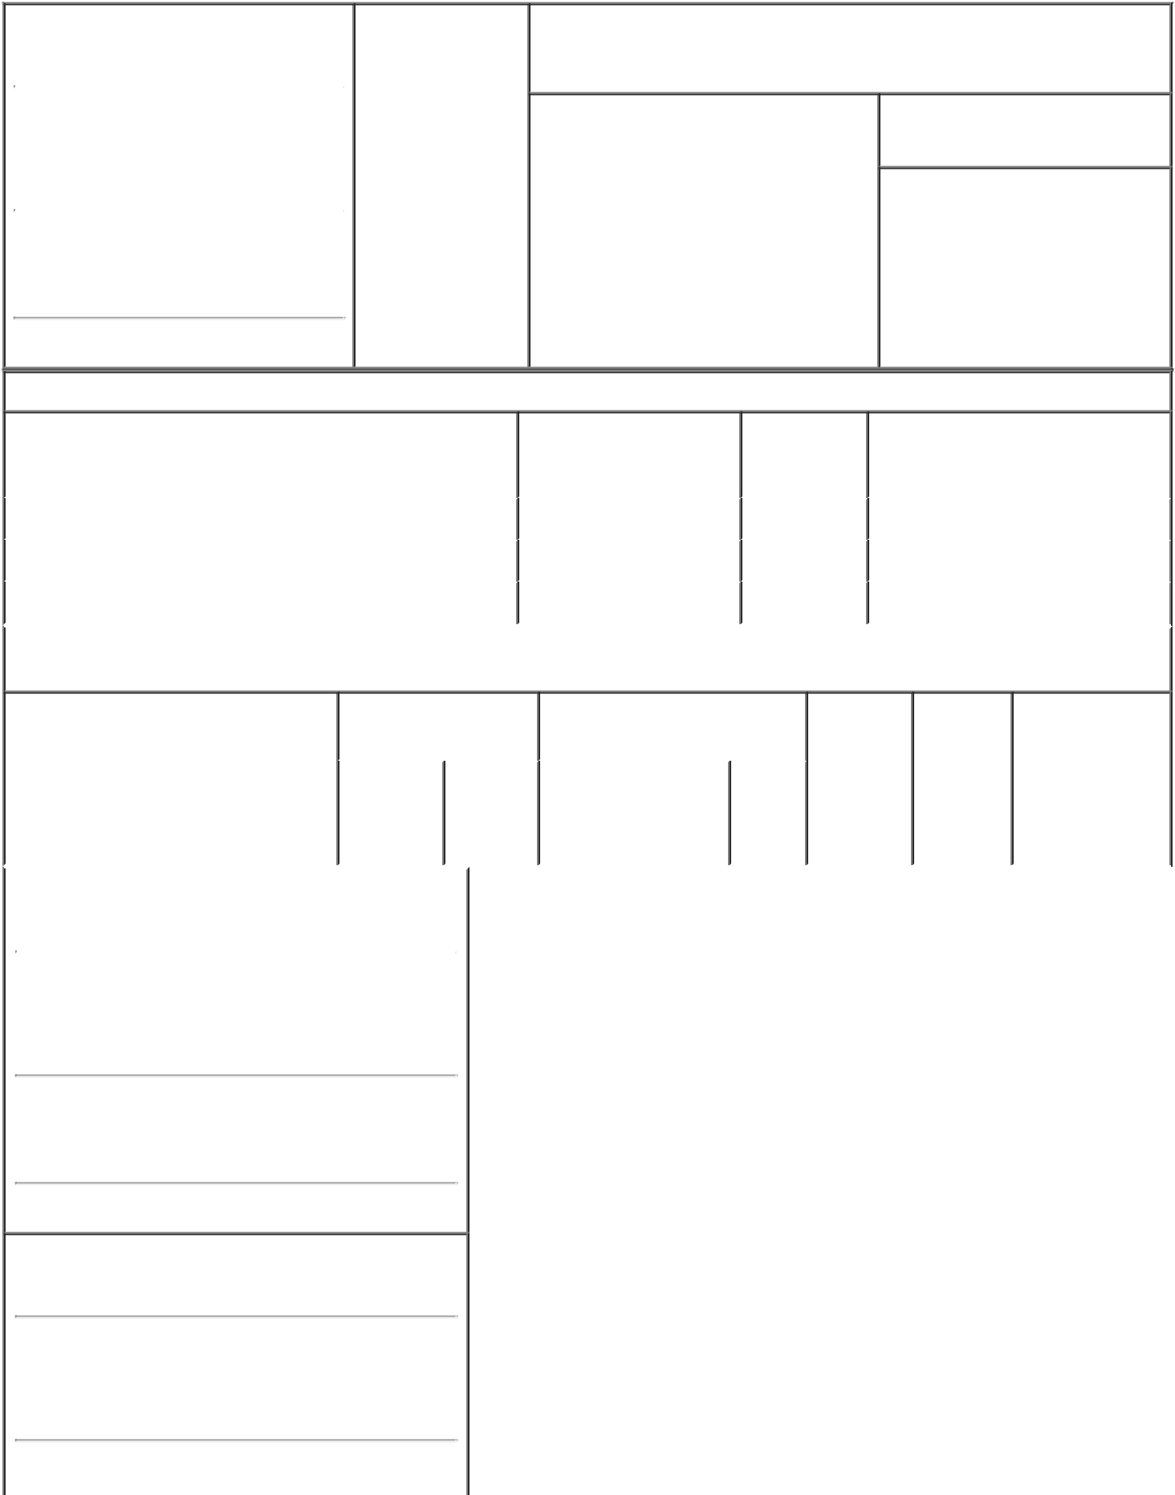

1. Name and Address of Reporting Person |  |  | * | 2. Date of Event
 |  |  |  | Requiring Statement
 | BVF PARTNERS L P/IL
 |  |  |  | (Month/Day/Year)
 |  |  |  | 10/28/2021

3. Issuer Name and Ticker or Trading Symbol

Repare Therapeutics Inc. [ RPTX ]

(Last) | (First) | (Middle)
44 MONTGOMERY STREET
40TH FL
(Street)
SAN
FRANCISCO ^{CA} |  | 94104

- Relationship of Reporting Person(s) to Issuer
(Check all applicable)

Director X 10% Owner

Officer (give Other (specify
title below) below)

- If Amendment, Date of Original Filed (Month/Day/Year)

- Individual or Joint/Group Filing (Check Applicable Line)

Form filed by One Reporting Person

- Form filed by More than One Reporting Person

(City) (State) (Zip)

Table I - Non-Derivative Securities Beneficially Owned

 | 1. Title of Security (Instr. 4) | 2. Amount of Securities | 3. Ownership | 4. Nature of Indirect Beneficial
 |  | Beneficially Owned (Instr. | Form: Direct | Ownership (Instr. 5)
 |  | 4) | (D) or Indirect
 |  |  | (I) (Instr. 5)
 | Common Stock⁽¹⁾ | 2,548,764 | _{D}(2)
 | Common Stock⁽¹⁾ | 1,903,361 | _{D}(3)
 | Common Stock⁽¹⁾ | 299,728 | _{D}(4)

Table II - Derivative Securities Beneficially Owned

(e.g., puts, calls, warrants, options, convertible securities)

 | 1. Title of Derivative Security (Instr. 4) |  |  |  |  |  | 2. Date Exercisable and |  |  |  | 3. Title and Amount of Securities |  | 4. | 5. | 6. Nature of
 |  |  |  |  |  |  | Expiration Date |  |  |  | Underlying Derivative Security |  | Conversion | Ownership | Indirect Beneficial
 |  |  |  |  |  |  | (Month/Day/Year) |  |  |  | (Instr. 4) |  | or Exercise | Form: | Ownership (Instr.
 |  |  |  |  |  |  |  |  |  |  |  |  | Price of | Direct (D) | 5)
 |  |  |  |  |  |  |  |  |  |  |  | Amount
 |  |  |  |  |  |  |  |  |  |  |  |  | Derivative | or Indirect
 |  |  |  |  |  |  |  |  |  |  |  | or | Security | (I) (Instr. 5)
 |  |  |  |  |  |  |  |  |  |  |  | Number
 |  |  |  |  |  |  | Date | Expiration |  |  |  | of
 |  |  |  |  |  |  | Exercisable | Date |  |  | Title | Shares
 | 1. Name and Address of Reporting Person*
 |  |  | BVF PARTNERS L P/IL
 |  |  | (Last) | (First) |  | (Middle)

44 MONTGOMERY STREET

40TH FL

(Street)
^{SAN} CA 94104

FRANCISCO

(City) (State) (Zip)

1. Name and Address of Reporting Person*
BIOTECHNOLOGY VALUE FUND L P

(Last) (First) (Middle)

44 MONTGOMERY STREET

40TH FL

(Street)

 |  | SAN | CA |  | 94104
 |  | FRANCISCO
 |  | (City) | (State) |  | (Zip)
1. Name and Address of Reporting Person*
 |  | BVF I GP LLC
 |  | (Last) | (First) |  | (Middle)

44 MONTGOMERY ST., 40TH FLOOR

(Street)
^{SAN} CA 94104

FRANCISCO

(City) (State) (Zip)

1. Name and Address of Reporting Person*
BIOTECHNOLOGY VALUE FUND II

LP

(Last) (First) (Middle)

44 MONTGOMERY STREET

40TH FL

(Street)
 |  | SAN | CA |  | 94104
 |  | FRANCISCO
 |  | (City) | (State) |  | (Zip)
1. Name and Address of Reporting Person*
 |  | BVF II GP LLC
 |  | (Last) | (First) |  | (Middle)

44 MONTGOMERY ST., 40TH FLOOR

(Street)
^{SAN} CA 94104

FRANCISCO

(City) (State) (Zip)

1. Name and Address of Reporting Person*
Biotechnology Value Trading Fund OS LP

 |  | (Last) | (First) |  | (Middle)
 |  | P.O. BOX 309 UGLAND HOUSE
(Street)
 |  | GRAND | E9 |  | KY1-1104
 |  | CAYMAN
 |  | (City) | (State) |  | (Zip)
1. Name and Address of Reporting Person*
 |  | BVF Partners OS Ltd.
 |  | (Last) | (First) |  | (Middle)

P.O. BOX 309 UGLAND HOUSE

(Street)

 |  | GRAND | E9 | KY1-1104
 |  | CAYMAN
 |  | (City) | (State) | (Zip)
1. Name and Address of Reporting Person*
 |  | BVF GP HOLDINGS LLC
 |  | (Last) | (First) | (Middle)

44 MONTGOMERY ST., 40TH FLOOR

(Street)
 |  | SAN |  | CA | 94104
 |  | FRANCISCO
 |  | (City) |  | (State) | (Zip)
1. Name and Address of Reporting Person*
 |  | BVF INC/IL
 |  | (Last) |  | (First) | (Middle)

44 MONTGOMERY STREET

40TH FL

(Street)
 |  | SAN | CA | 94104
 |  | FRANCISCO
 |  | (City) | (State) | (Zip)
1. Name and Address of Reporting Person*
 |  | LAMPERT MARK N
 |  | (Last) | (First) | (Middle)

44 MONTGOMERY STREET

40TH FL

(Street)
^{SAN} CA 94104

FRANCISCO

(City) (State) (Zip)

Explanation of Responses:

- This Form 3 is filed jointly by Biotechnology Value Fund, L.P. ("BVF"), Biotechnology Value Fund II, L.P. ("BVF2"), Biotechnology Value Trading Fund OS LP ("Trading Fund OS"), BVF Partners OS Ltd. ("Partners OS"), BVF I GP LLC ("BVF GP"), BVF II GP LLC ("BVF2 GP"), BVF GP Holdings LLC ("BVF GPH"), BVF Partners L.P. ("Partners"), BVF Inc. and Mark N. Lampert (collectively, the "Reporting Persons"). Each of the Reporting Persons is a member of a Section 13(d) group. Each of the Reporting Persons disclaims beneficial ownership of the securities reported herein except to the extent of his or its pecuniary interest therein.

- Securities owned directly by BVF. As the general partner of BVF, BVF GP may be deemed to beneficially own the securities owned directly by BVF. As the sole member of BVF GP, BVF GPH may be deemed to beneficially own securities owned directly by BVF. As the investment manager of BVF, Partners may be deemed to beneficially own the securities owned directly by BVF. As the investment adviser and general partner of Partners, BVF Inc. may be deemed to beneficially own the securities owned directly by BVF. As a director and officer of BVF Inc., Mr. Lampert may be deemed to beneficially own the securities owned directly by BVF.

- Securities owned directly by BVF2. As the general partner of BVF2, BVF2 GP may be deemed to beneficially own the securities owned directly by BVF2. As the sole member of BVF2 GP, BVF GPH may be deemed to beneficially own securities owned directly by BVF2. As the investment manager of BVF2, Partners may be deemed to beneficially own the securities owned directly by BVF2. As the investment adviser and general partner of Partners, BVF Inc. may be deemed to beneficially own the securities owned directly by BVF2. As a director and officer of BVF Inc., Mr. Lampert may be deemed to beneficially own the securities owned directly by BVF2.

- Securities owned directly by Trading Fund OS. As the general partner of Trading Fund OS, Partners OS may be deemed to beneficially own the securities owned directly by Trading Fund OS. As the investment manager of Trading Fund OS and the sole member of Partners OS, Partners may be deemed to beneficially own the securities owned directly by Trading Fund OS. As the investment adviser and general partner of Partners, BVF Inc. may be deemed to beneficially own the securities owned directly by Trading Fund OS. As a director and officer of BVF Inc., Mr. Lampert may be deemed to beneficially own the securities owned directly by Trading Fund OS.

BVF Partners L.P., By:
BVF Inc., its general |  |  |  |  |  |  |  | 11/08/2021
partner, By: /s/ Mark N.
Lampert, President
Biotechnology Value |  |  |  |  |  |  |  | 11/08/2021
Fund, L.P., By: BVF
Partners L.P., its
investment manager, By:
BVF Inc., its general

partner, By: /s/ Mark N.
Lampert, President

BVF I GP LLC, By: BVF

GP HOLDINGS LLC, its

sole member, By: /s/ Mark

N. Lampert, Chief
Executive Officer

Biotechnology Value Fund

II, L.P., By: BVF Partners

L.P., its investment
manager, By: BVF Inc., its

general partner, By: /s/
Mark N. Lampert,
President

BVF II GP LLC, By: BVF

GP HOLDINGS LLC, its

sole member, By: /s/ Mark

N. Lampert, Chief
Executive Officer

BVF Partners OS Ltd., By:

BVF Partners L.P., its sole

member, By: BVF Inc., its

general partner, By: /s/
Mark N. Lampert,
President

Biotechnology Value
Trading Fund OS LP, By:

BVF Partners L.P., its
investment manager, BVF

Inc., its general partner,

By: /s/ Mark N. Lampert,

President

BVF GP Holdings LLC,
By: /s/ Mark N. Lampert,

Chief Executive Officer

11/08/2021

11/08/2021

11/08/2021

11/08/2021

11/08/2021

11/08/2021

BVF Inc., By: /s/ Mark N. |  |  | 11/08/2021
Lampert, President
/s/ Mark N. Lampert |  |  |  | 11/08/2021

** Signature of Reporting | Date
Person
Reminder: Report on a separate line for each class of securities beneficially owned directly or indirectly.
* If the form is filed by more than one reporting person, see Instruction 5 (b)(v).

- Intentional misstatements or omissions of facts constitute Federal Criminal Violations See 18 U.S.C. 1001 and 15 U.S.C. 78ff(a). Note: File three copies of this Form, one of which must be manually signed. If space is insufficient, see Instruction 6 for procedure.
Persons who respond to the collection of information contained in this form are not required to respond unless the form displays a currently valid OMB Number.

