SEC Form 4

FORM 4

Check this box if no longer subject to Section 16. Form 4 or Form 5 obligations may continue. See Instruction 1(b).

UNITED STATES SECURITIES AND EXCHANGE COMMISSION
Washington, D.C. 20549
 |  | OMB APPROVAL
STATEMENT OF CHANGES IN BENEFICIAL OWNERSHIP
 |  | OMB Number: | 3235-0287
 |  | Estimated average burden
Filed pursuant to Section 16(a) of the Securities Exchange Act of 1934 |  | hours per response: | 0.5
or Section 30(h) of the Investment Company Act of 1940
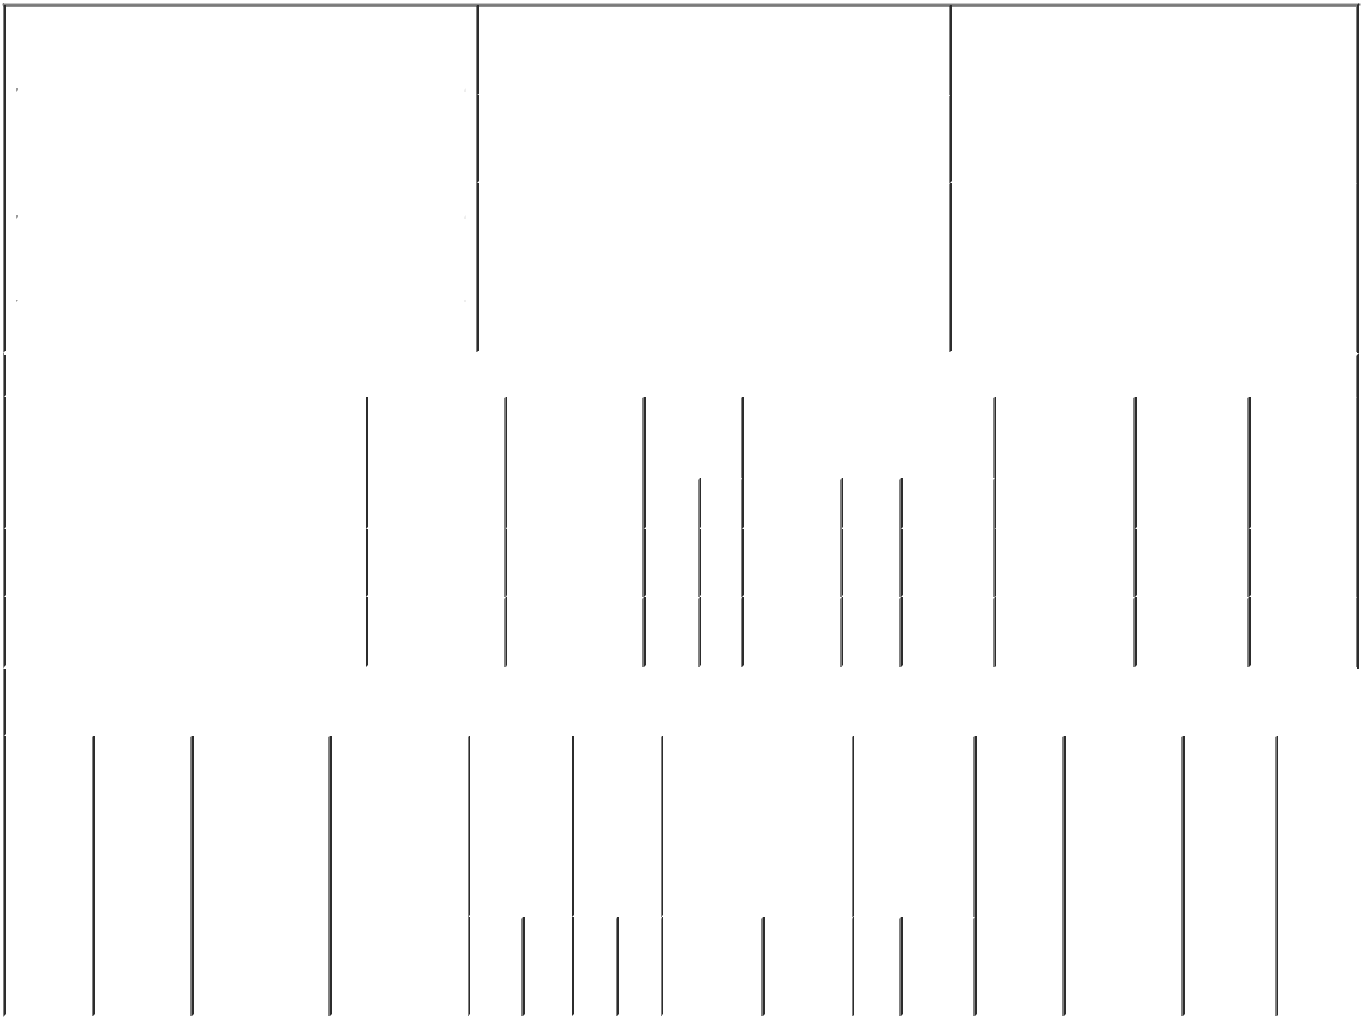

 | 1. Name and Address of Reporting Person* |  |  |  |  |  |  |  |  | 2. Issuer Name and Ticker or Trading Symbol |  |  |  |  |  |  | 5. Relationship of Reporting Person(s) to Issuer
 |  | GADICKE ANSBERT |  |  |  |  |  |  |  | Repare Therapeutics Inc. [ RPTX ] |  |  |  |  |  |  | (Check all applicable)
 |  |  |  |  |  |  |  |  |  |  |  |  |  |  |  |  |  |  |  |  | Director |  |  | X 10% Owner
 |  |  |  |  |  |  |  |  |  |  |  |  |  |  |  |  |  |  |  |  | Officer (give title |  |  | Other (specify
 |  |  |  |  |  |  |  |  |  | 3. Date of Earliest Transaction (Month/Day/Year)
 |  | (Last) | (First) |  |  | (Middle) |  |  |  |  |  |  |  |  |  |  |  |  |  |  | below) |  |  | below)
 |  | C/O MPM CAPITAL |  |  |  |  |  |  | 06/14/2021
 |  | 450 KENDALL STREET
 |  |  |  |  |  |  |  |  |  | 4. If Amendment, Date of Original Filed (Month/Day/Year) |  |  |  |  |  |  | 6. Individual or Joint/Group Filing (Check Applicable
 |  |  |  |  |  |  |  |  |  |  |  |  |  |  |  |  | Line)
 | (Street) |  |  |  |  |  |  |  |  |  |  |  |  |  |  |  |  |  | X Form filed by One Reporting Person
 |  | CAMBRIDGE MA |  |  |  | 02142 |  |  |  |  |  |  |  |  |  |  |  |  |  |  | Form filed by More than One Reporting
 |  |  |  |  |  |  |  |  |  |  |  |  |  |  |  |  |  |  |  |  | Person
 |  | (City) | (State) |  |  | (Zip)
 |  |  |  |  | Table I - Non-Derivative Securities Acquired, Disposed of, or Beneficially Owned
 | 1. Title of Security (Instr. 3) |  |  |  |  | 2. Transaction |  |  |  | 2A. Deemed |  |  | 3. | 4. Securities Acquired (A) or |  |  |  |  |  |  | 5. Amount of |  | 6. Ownership |  | 7. Nature of
 |  |  |  |  |  | Date |  |  |  | Execution Date, |  |  | Transaction | Disposed Of (D) (Instr. 3, 4 and 5) |  |  |  |  |  |  | Securities |  | Form: Direct |  | Indirect
 |  |  |  |  |  | (Month/Day/Year) if any |  |  |  |  |  |  | Code (Instr. |  |  |  |  |  |  |  | Beneficially |  | (D) or Indirect |  | Beneficial
 |  |  |  |  |  |  |  |  |  | (Month/Day/Year) |  |  | 8) |  |  |  |  |  |  |  | Owned Following |  | (I) (Instr. 4) |  | Ownership
 |  |  |  |  |  |  |  |  |  |  |  |  |  |  |  |  |  |  |  |  | Reported |  |  |  | (Instr. 4)
 |  |  |  |  |  |  |  |  |  |  |  |  | Code V | Amount | (A) or | Price |  |  |  |  | Transaction(s)
 |  |  |  |  |  |  |  |  |  |  |  |  |  |  | (D) |  |  |  |  |  | (Instr. 3 and 4)
 | Common Shares |  |  |  |  | 06/14/2021 |  |  |  |  |  |  | _{S}(1) | 2,000⁽²⁾ | D | $33.09⁽³⁾ |  |  |  |  | 4,080,995 |  |  | I | See
 |  |  |  |  |  |  |  |  |  |  |  |  |  |  |  |  |  |  |  |  |  |  |  |  | Footnote⁽⁴⁾
 | Common Shares |  |  |  |  | 06/16/2021 |  |  |  |  |  |  | _{S}(1) | 4,227⁽⁵⁾ | D | $33.33⁽⁶⁾ |  |  |  |  | 4,076,768 |  |  | I | See
 |  |  |  |  |  |  |  |  |  |  |  |  |  |  |  |  |  |  |  |  |  |  |  |  | Footnote⁽⁷⁾
 |  |  |  |  |  | Table II - Derivative Securities Acquired, Disposed of, or Beneficially Owned
 |  |  |  |  |  | (e.g., puts, calls, warrants, options, convertible securities)
 | 1. Title of |  | 2. | 3. Transaction |  | 3A. Deemed |  |  | 4. |  | 5. Number 6. Date Exercisable and |  |  |  | 7. Title and |  |  |  | 8. Price of |  |  | 9. Number of |  | 10. |  | 11. Nature
 | Derivative |  | Conversion | Date |  | Execution Date, |  |  | Transaction |  | of |  | Expiration Date |  | Amount of |  |  |  | Derivative |  |  | derivative |  | Ownership |  | of Indirect
 | Security |  | or Exercise | (Month/Day/Year) if any |  |  |  |  | Code (Instr. |  | Derivative |  | (Month/Day/Year) |  | Securities |  |  |  | Security |  |  | Securities |  | Form: |  | Beneficial
 | (Instr. 3) |  | Price of |  |  | (Month/Day/Year) |  |  | 8) |  | Securities |  |  |  | Underlying |  |  |  | (Instr. 5) |  |  | Beneficially |  | Direct (D) |  | Ownership
 |  |  | Derivative |  |  |  |  |  |  |  | Acquired |  |  |  | Derivative |  |  |  |  |  |  | Owned |  | or Indirect |  | (Instr. 4)
 |  |  | Security |  |  |  |  |  |  |  | (A) or |  |  |  | Security (Instr. |  |  |  |  |  |  | Following |  | (I) (Instr. 4)
 |  |  |  |  |  |  |  |  |  |  | Disposed |  |  |  | 3 and 4) |  |  |  |  |  |  | Reported
 |  |  |  |  |  |  |  |  |  |  | of (D) |  |  |  |  |  |  |  |  |  |  | Transaction(s)
 |  |  |  |  |  |  |  |  |  |  | (Instr. 3, 4 |  |  |  |  |  |  |  |  |  |  | (Instr. 4)
 |  |  |  |  |  |  |  |  |  |  | and 5)
 |  |  |  |  |  |  |  |  |  |  |  |  |  |  |  | Amount
 |  |  |  |  |  |  |  |  |  |  |  |  |  |  |  | or
 |  |  |  |  |  |  |  |  |  |  |  |  |  |  |  | Number
 |  |  |  |  |  |  |  |  |  |  |  |  | Date | Expiration |  | of
 |  |  |  |  |  |  |  |  | Code V |  | (A) (D) |  | Exercisable Date |  | Title | Shares

Explanation of Responses:

- Transaction effected pursuant to a plan established pursuant to Rule 10b5-1 on 3/31/2021.

- The shares were sold as follows: 852 by MPM BioVentures 2014, L.P. ("BV 2014"), 29 by MPM Asset Management Investors BV2014 LLC ("AM BV2014") and 1,119 by UBS Oncology Impact Fund L.P. ("UBS Oncology").

- The price reported in Column 4 is a weighted average price. These shares were sold in multiple transactions at prices ranging from $32.95 to $33.57 inclusive. The Reporting Person undertakes to provide to the Issuer, any security holder of the Issuer, or the staff of the Securities and Exchange Commission, upon request, full information regarding the number of shares sold at each separate price within the range set forth in this footnote.

- The shares are held as follows: 2,121,245 by BV 2014, 135,843 by MPM BioVentures 2014(B), L.P. ("BV 2014(B)"), 73,014 by AM BV2014 and 1,750,893 by UBS Oncology. MPM BioVentures 2014 GP LLC and MPM BioVentures 2014 LLC ("BV LLC") are the direct and indirect general partners of BV 2014 and BV 2014(B). BV LLC is the manager of AM BV2014. Ansbert Gadicke is a managing director of BV LLC. MPM Oncology Impact Management GP LLC ("Oncology GP LLC") is the General Partner of MPM Oncology Impact Management LP, the General Partner of Oncology Impact Fund (Cayman) Management L.P., the General Partner of UBS Oncology Impact Fund, L.P. Ansbert Gadicke is the Managing Member of Oncology GP LLC. The Reporting Person disclaims beneficial ownership of the securities except to the extent of his pecuniary interest therein.

- The shares were sold as follows: 1,800 by BV 2014, 62 by AM BV2014 and 2,365 by UBS Oncology.

- The price reported in Column 4 is a weighted average price. These shares were sold in multiple transactions at prices ranging from $32.95 to $33.66 inclusive. The Reporting Person undertakes to provide to the Issuer, any security holder of the Issuer, or the staff of the Securities and Exchange Commission, upon request, full information regarding the number of shares sold at each separate price within the range set forth in this footnote.

- The shares are held as follows: 2,119,445 by BV 2014, 135,843 by BV 2014(B), 72,952 by AM BV2014 and 1,748,528 by UBS Oncology. The Reporting Person disclaims beneficial ownership of the securities except to the extent of his pecuniary interest therein.

Remarks:

/s/ Ansbert Gadicke |  | 06/16/2021
** Signature of Reporting Person |  | Date

Reminder: Report on a separate line for each class of securities beneficially owned directly or indirectly.

* If the form is filed by more than one reporting person, see Instruction 4 (b)(v).

- Intentional misstatements or omissions of facts constitute Federal Criminal Violations See 18 U.S.C. 1001 and 15 U.S.C. 78ff(a). Note: File three copies of this Form, one of which must be manually signed. If space is insufficient, see Instruction 6 for procedure.
Persons who respond to the collection of information contained in this form are not required to respond unless the form displays a currently valid OMB Number.

